A) Customer Strategy – Understanding our customers.

Customers are at the heart of everything we do here at ChemCorp.

i) What products customers buy the most and what products are bought the least?

By total Revenue customers bought Chemical K the most. The least purchased chemical was Chemical A.

Sheet "Revenue of Product sold most"

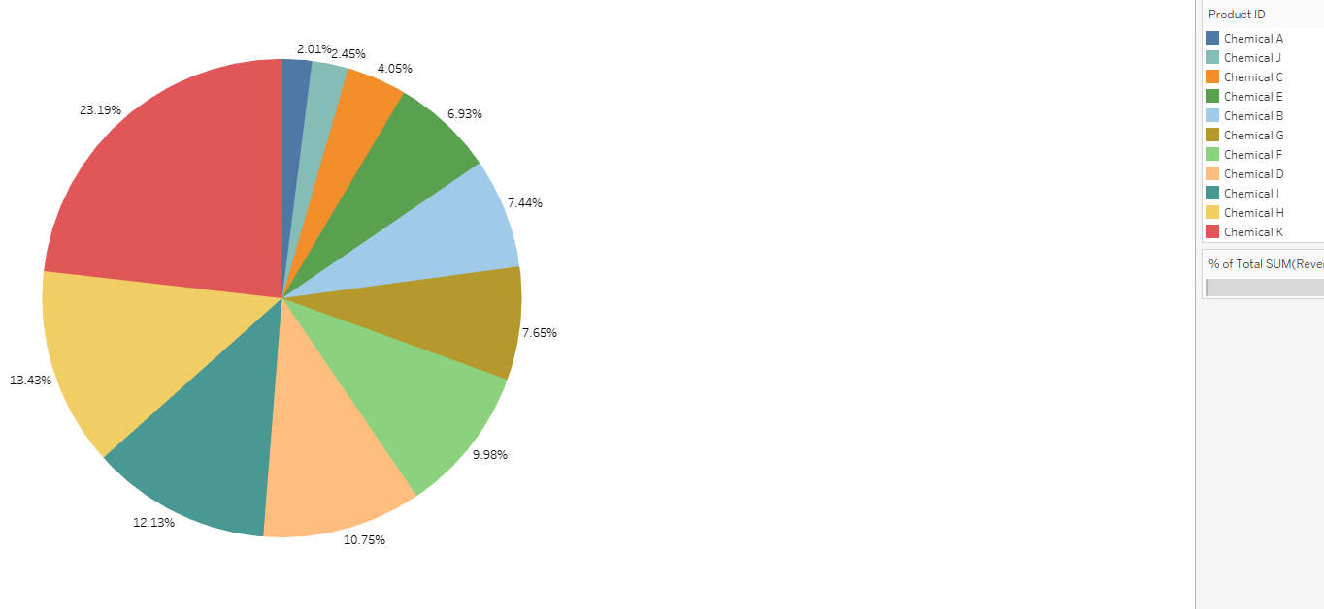

ii) Where most products are being bought

Most of the product is bought in North Central

Sheet "Region that bought most Chemical"

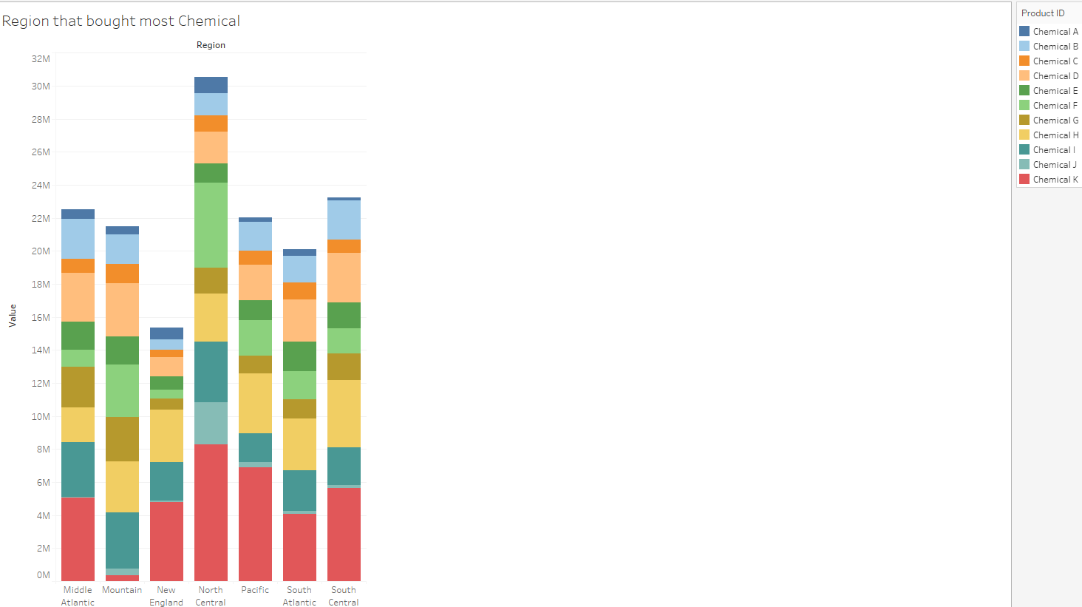

iii) How seasonality plays into the purchase of these products. Are any of our industries or chemicals impacted by seasonal variation?

I have 1-year worth of data and there are 2 chemical that seem to spike. I took median of chemical sold and then plotted against the month. As you can see there are spikes of chemical H. Chemical H seems to spike in May and November. Chemical K seems to have spikes in March and June, then it slowly declines and seems to inline starting in November. The other chemical seems to have some peaks and troughs but they seem more wave and hover around a range.

Sheet "Seasonal Sales"

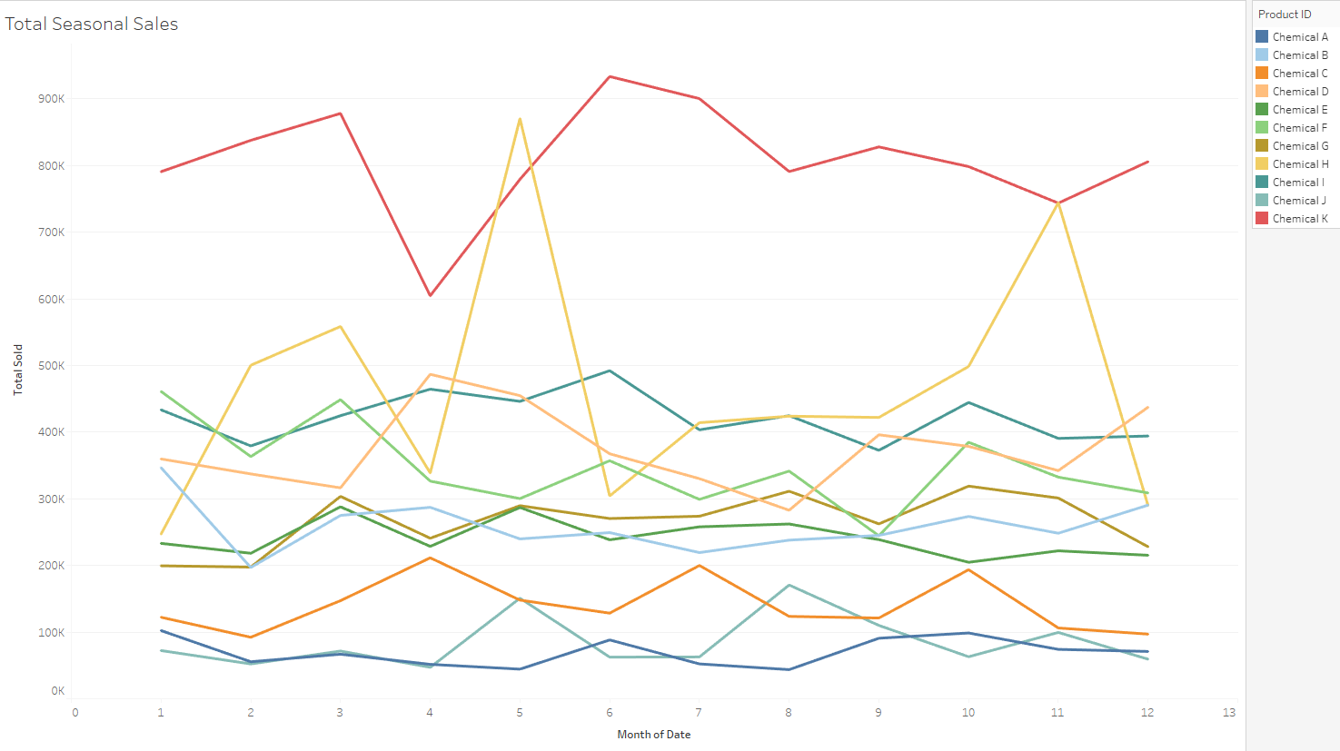

B) Market Opportunities – As we look to the future, what opportunities are we

missing?

i)Which industry provides the most revenue to ChemCorp at this point in time?

Looking at the graph Paper and Packing seems to have the vast market share of the revenue

Sheet “Revenue by Industry”

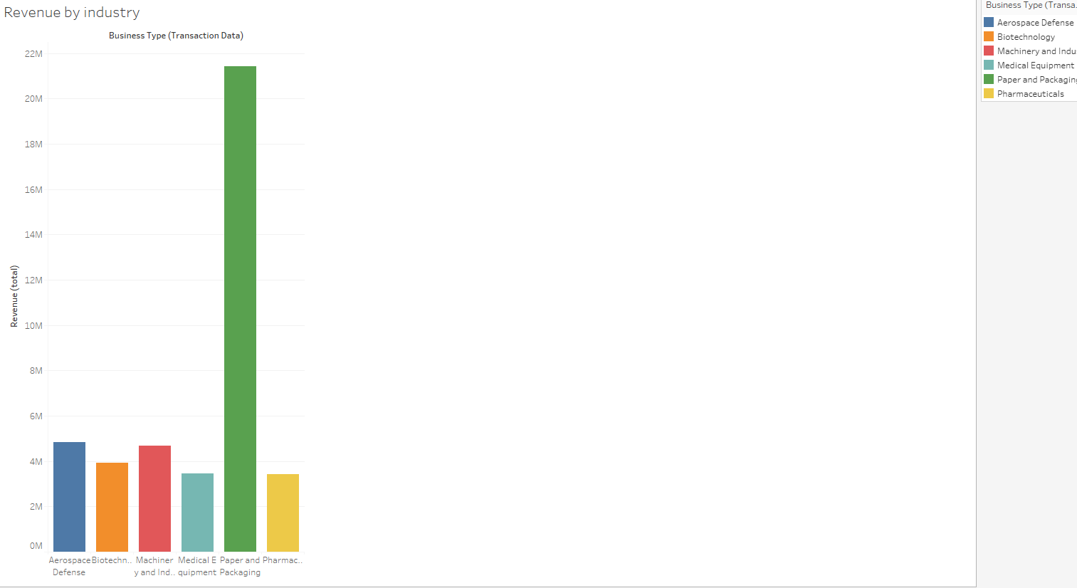

ii)What industries have the highest profit margins and how is this reflected in the number of business customers per segment?

The highest profit margin is Biotechnology

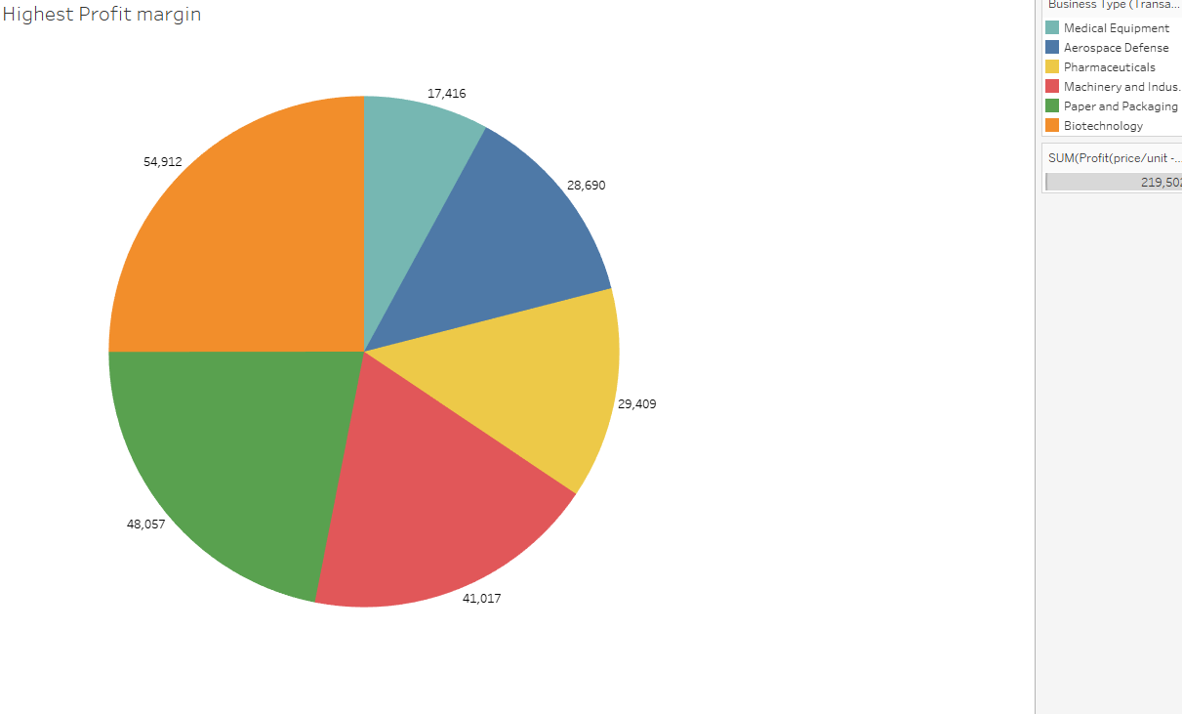 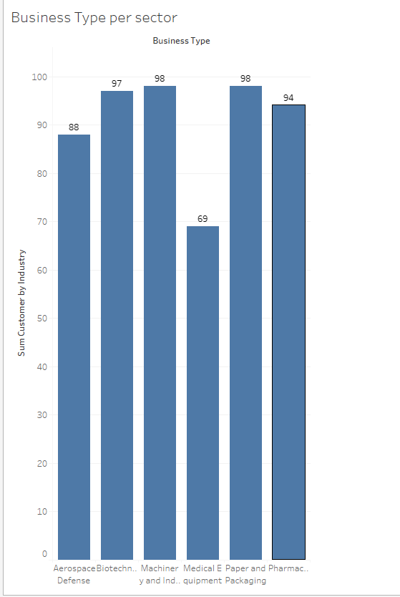

iii) What products provide the highest profitability?

From the chart below I had to take average price – average cost as all contract sells the chemical at different price. Chemical G of profit price is $28.20.

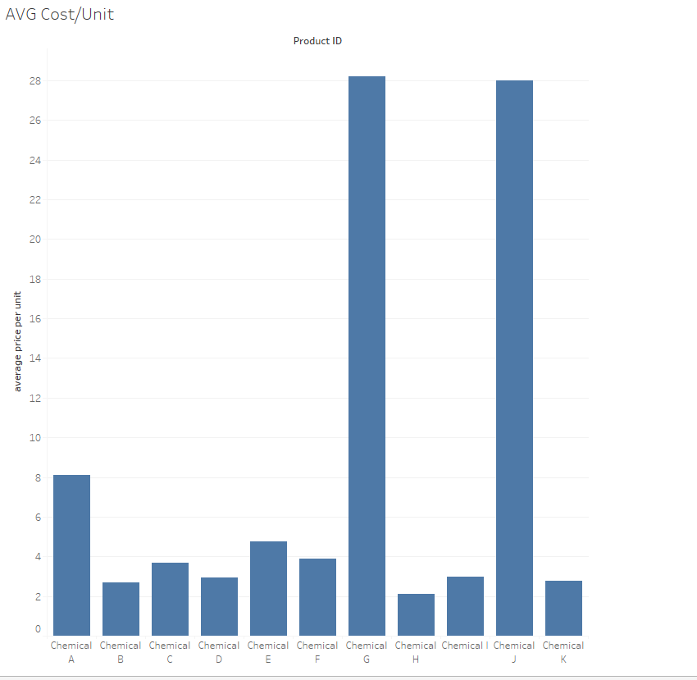

C) Product Divestment – We have a limited amount of capital; we need to make sure we’re spending the right dollars in the areas which have the highest growth potential. This means doing some potential cleaning of our existing product inventory and weeding out low performing categories.

i.) Which industries have the lowest overall profitability?

ii.) What products have the lowest profitability and number of business customers?

**1. Understanding the Market Segment – How do the segments differ?**

i.) For each segment, what % of customers in that segment purchase this specific chemical?

I have graphed the segment by region and type of chemical is used

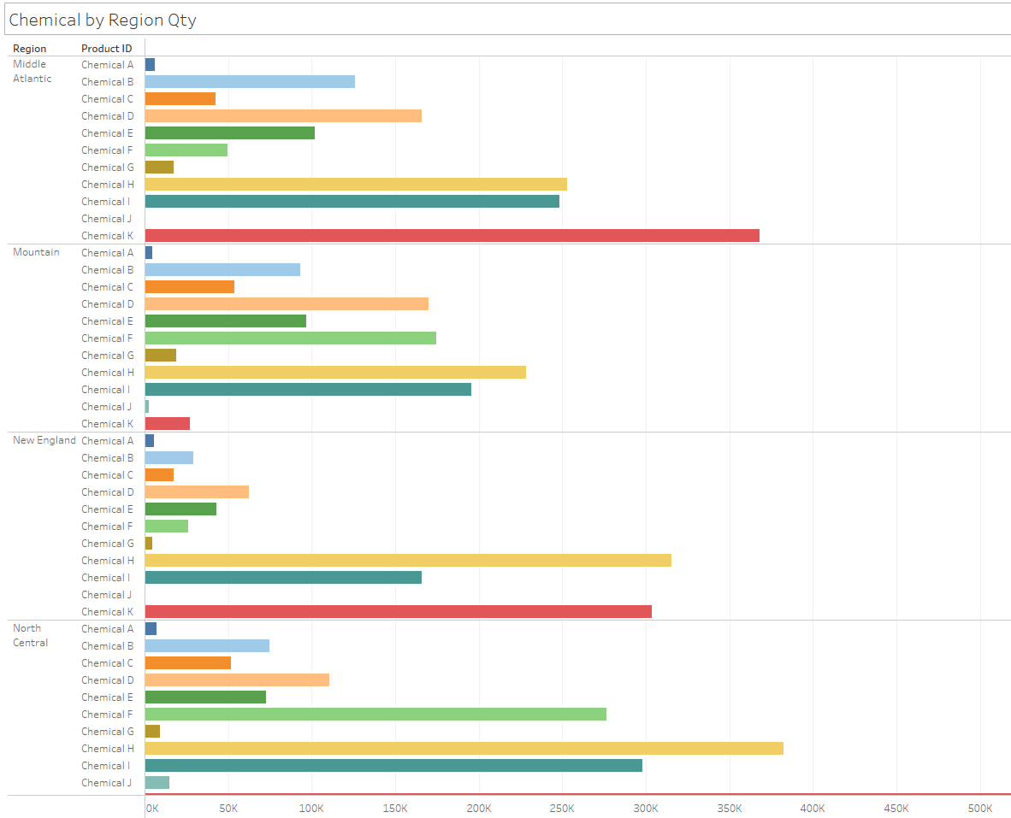

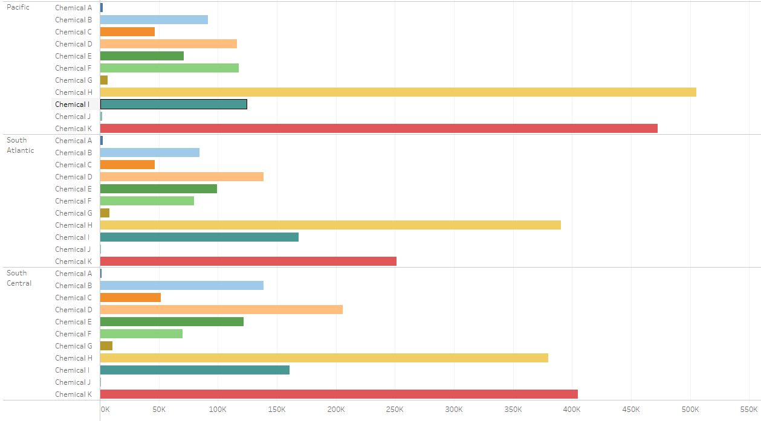

ii.) What is the revenue breakdown per industry segment? (i.e. Which industries provide the largest inflow of revenues?)

Paper and Packaging provides the largest revenue

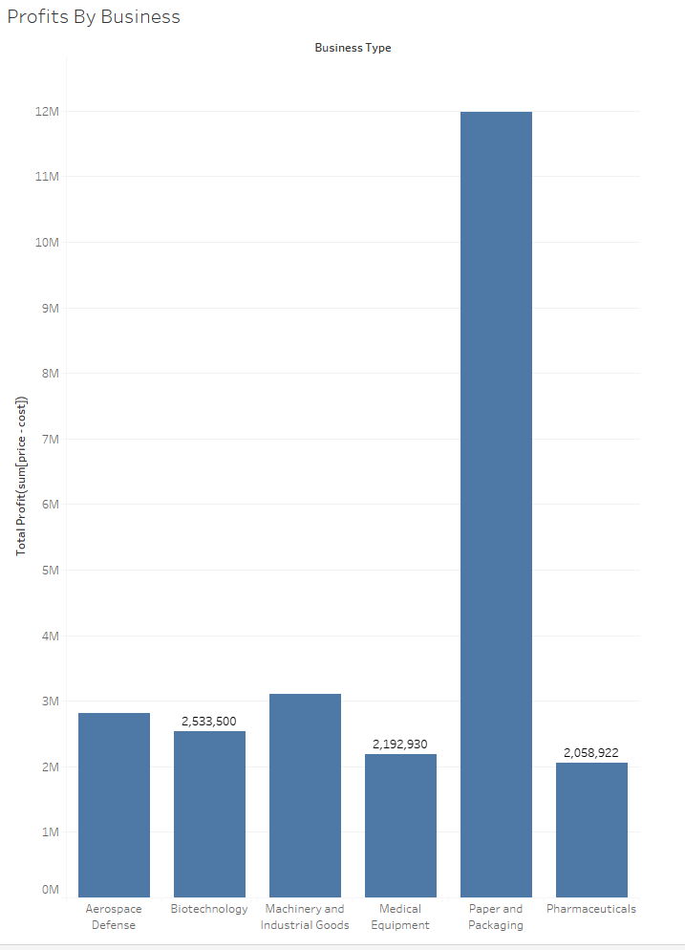

iii.) Does there exist any seasonality where industry sales drop or rise rapidly? (Perhaps consider whether there is any fluctuation of individual chemical sales.) iv. What is the geographic distribution of each segment?

I have 1-year worth of data and there are 2 chemical that seem to spike. I took median of chemical sold and then plotted against the month. As you can see there are spikes of chemical H. Chemical H seems to spike in May and November. Chemical K seems to have spikes in March and June, then it slowly declines and seems to incline starting in November. The other chemical seems to have some peaks and troughs, but they seem more like a wave and hover around a range.

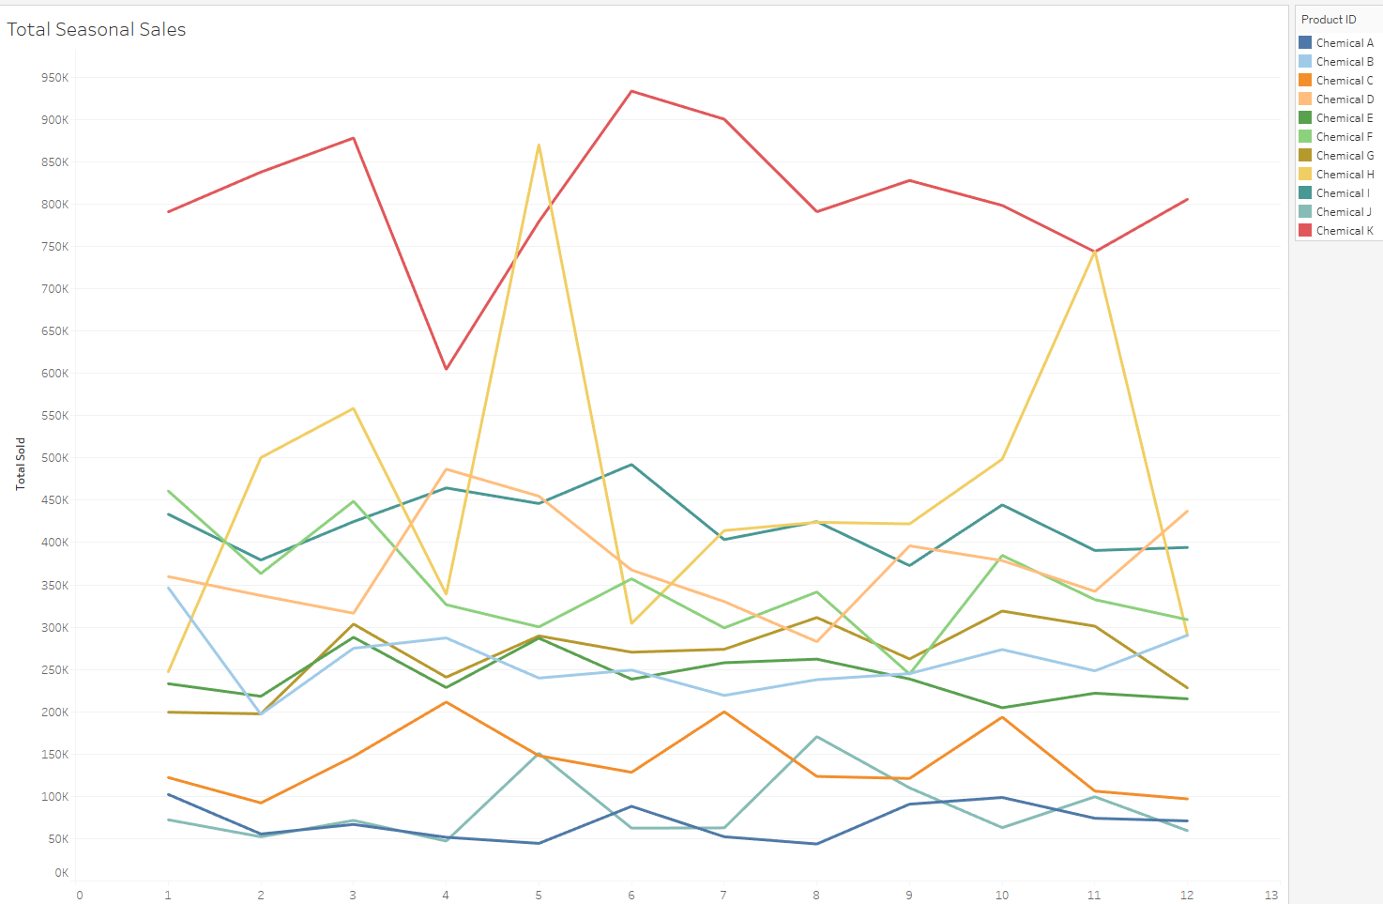

**2. Market Opportunity – Are there any existing opportunities ChemCorp should focus on when examining its existing customer segments?**

i. Of the six segments ChemCorp’s business has focused on, which segments yield the highest average profit margin(s) on a % basis?

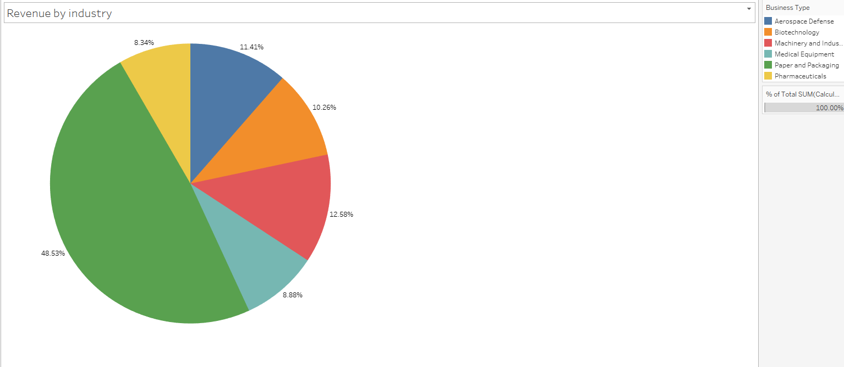

ii. Beyond profit margin %, how does this segment compare with the number of customers in that segment? (I.e. Create a graph which addresses both the profit margin % versus the number of businesses in that segment)

iii. Of the segment which proves most attractive, which products are responsible for driving the highest profit?

**3)Product Divestment – Of the current products that ChemCorp produces, do there exist any chemicals or industries that they should divest themselves of? Copying or posting is an infringement of copyright.**

Of the six segments ChemCorp’s business has focused on, do any negative or very low-profit margins exist?

i.) None of the 6 businesses shows a negative profit but the lowest profit is Pharmaceuticals. It has profit of $2,058,922 in 2015

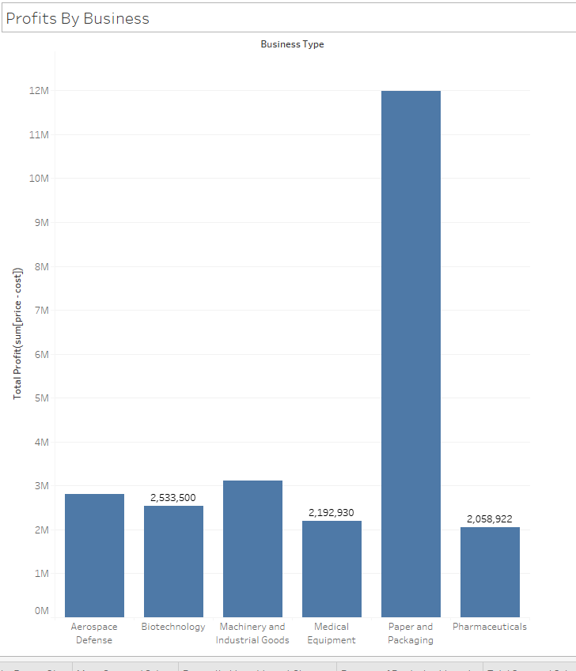

ii.) Identify insights and/or recommendations to the management team. (You will create a slide deck based on these findings later on in the course.) 1. If the company were to divest in a particular area, where should they focus their resources (i.e. Instead of using resources for Industry X or Chemical Y, they should focus their efforts on Chemical B.)

I would consider either getting rid of Chemical A or J. They are the lowest chemical in terms revenue. The surprising fact is that chemical J and G are also product with greatest margins. I would consider keeping G and J if I could sell more of those chemicals.

Below is the image of (Price*quantity) – (cost*quantity)

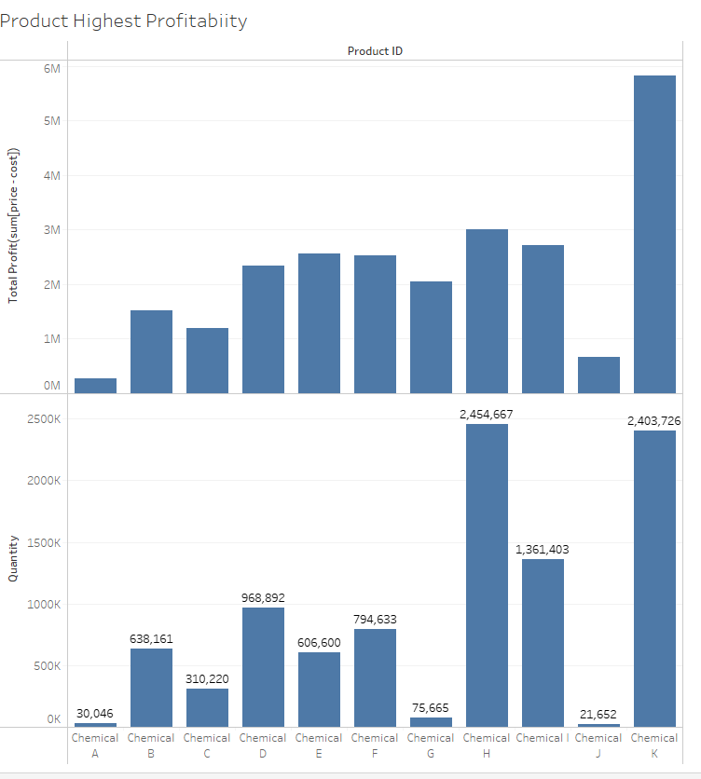

Below Graph shows avg(price) – avg(cost) as that is only way I can tell what is the average profit margins per chemical

